- Go to http://galesupport.com/michlookup/

- Type in the name of your library or school

- Click on the blue button that says “Click here to get your MARC Records”

- The MARC records page within the Gale Support site will display with customized url's for your individual location

- To download the MARC records for all of your GVRL titles, leave the “All eBooks” selection next to the “Merge Records by” section, and click on the “Generate your Customized MARC Records” link. (See image below)

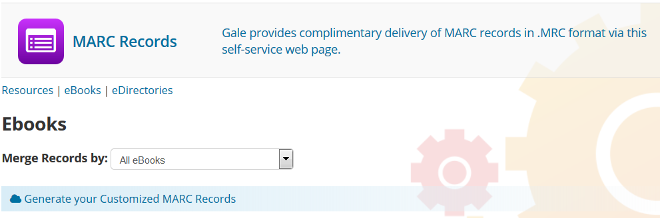

- To download the MARC records for the 50 new GVRL titles separately, click on the down arrow to select “MeL 2015” and click on the “Generate your Customized MARC Records” link. (See image below)

