Available Items:

20 - Dell 1908FP monitors
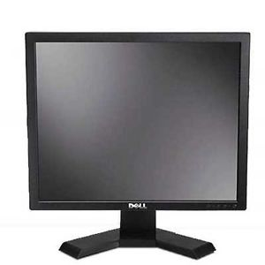

2 – Dell 1905fp monitors
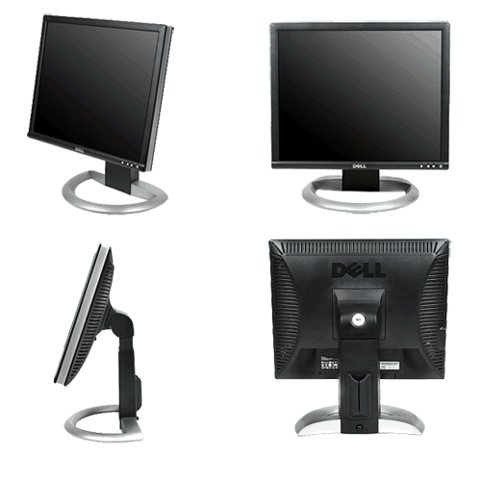

23 – Dell L100 keyboards
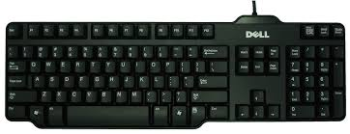

10 – Metrologic scanner stands (scanners not included – stands only)
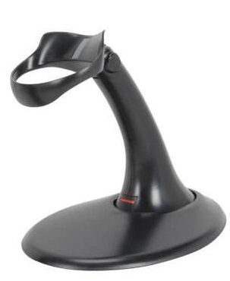

3 – 3M privacy screens model PF319
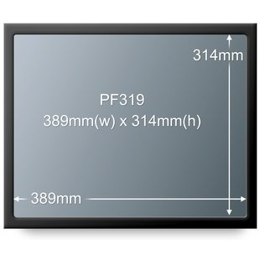

Please Note:
Various other monitors, keyboards, peripherals and devices also available to browse upon visit. All are free to take.
All items are used condition; free to any library but please be aware that these items are as-is, no guarantees will be made regarding working state. Once they have been claimed, they are the property and responsibility of the receiver.
On site pick up must be arranged – items cannot be delivered or shipped. Call or email Purchasing Assistant to check availability and arrange pick up times:
Heather Goupil
goupilh@cadl.org
517-334-1531

