The Carson City Public Library will welcome Michigan Notable Book Award winning author
Sean Madigan Hoen on Saturday April 25, at 2 p.m. at the library. Space is limited please call to make your reservation 989-584-3680.

Eighteen-year-old Sean Madigan Hoen was struggling to keep his involvement in the city’s hardcore punk scene a secret from his family. Then he learned that his father, too, had a second life—as a crack addict. Songs Only You Know begins in the '90s and spans a decade during which the family fights to hold itself together. Sean’s father cycles from rehab to binge, his heartsick sister spirals into depression, and his mother works to spare what can be spared. Meanwhile, Sean seeks salvation in a community of eccentrics and outsiders. But the closer Sean comes to realizing his musical dream, the further he drifts from his family and himself. By turns heartbreaking and mordantly funny, Songs Only You Know is a fierce, compassionate rendering of the chaos and misadventure of a young man’s life.
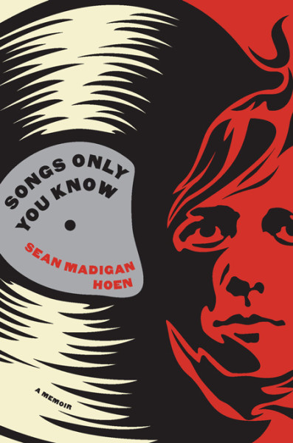
photo by Nathaniel Shannon
Sean Madigan Hoen (pronounced Hayne) was raised in Dearborn, Michigan. His short stories and prose have been published in BOMB Magazine, where he was awarded the 2011 Fiction Award, as well as The American Literary Review, Paste Magazine, and others. He was awarded a 2010 teaching fellowship from Columbia University. More recently, he’s been working on a short story collection and a novel. Hoen has taught at Columbia University and Western Michigan University. He currently lives in Brooklyn, New York and teaches creative writing at Rutgers University.
Michigan Notable Books is an annual program that features a juried selection of twenty outstanding titles - including fiction and nonfiction - published the previous year and set in Michigan or in the Great Lakes or written by a Michigan author. The program includes a tour of libraries by the Michigan Notable authors who visit communities across the state, engaging residents in readings, learning and dialogue. Michigan Notable Books inspires the people of Michigan to read and to connect with each other and the places where they live. The program broadens people’s understanding of Michigan’s history and culture by raising awareness about the events and ideas that helped shape Michigan, as we know it today.

This program is made possible thanks to support from the Michigan Humanities Council, the Library of Michigan, the Library of Michigan Foundation, Meijer, and the Michigan Center for the Book. Media partners are MittenLit.com., City Pulse, Dome, Queue Advertising and Gennara Photography.

