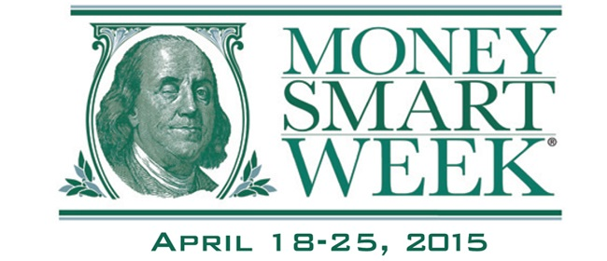

**“Money Smart Week @ your library” is a national initiative between the American Library Association and the Federal Reserve Bank  
to provide financial literacy programming.**

**The Warren Public Library is proud to host the following three events to help us keep our ledgers in the black and our pockets filled with green!**

**1:** **Find Work You Love: Five Ways to Transition from an Ordinary Job to an Extraordinary Career! with Career Coach Julie Carr** - Frustrated with your job? Then this is the workshop for you! Turn that job into a rewarding career with these helpful strategies and tips.

**2: Family Financial Planning** - This is a seminar on general financial planning for you and your family.  A representative from Hantz Group will cover various topics relating to: budgeting, debt management, mortgages, college financing, and more.  There will be a session for the kids too!

**3: Marriage & Money with Heidi McCarroll of Primerica** – This session is aimed at giving married couples a no-nonsense approach to setting and achieving financial goals. You will learn strategies to set short and long term goals and how to build a budget.

**Miller Branch Library**

**Family Financial Planning**

**for adults and kids**

**Monday, April 20 @ 6:30-7:30 p.m.**

**Civic Center Library**

**Find Work You Love: Five Ways to Transition from an Ordinary Job to an Extraordinary Career!**

**Monday, April 20 @ 6:00-8:00 p.m.**

**Civic Center Library**

**Marriage & Money with Heidi McCarroll of Primerica**

**Wednesday, April 22 @ 6:00-8:00 p.m.**

**\*Please note change of date\***

C:\Users\CIRC EAST\Desktop\Flyer Stuff\Follow us.jpg