Cool Running Couch-to-5K Running Plan
http://www.coolrunning.com/engine/2/2_3/181.shtml

Wk | Workout 1 | Workout 2 | Workout 3
1 | Brisk 5-minute warmup walk  Alternate:  - 60 sec jogging  - 90 sec walking  Total of 20 minutes | Brisk 5-minute warmup walk  Alternate:  - 60 sec jogging  - 90 sec walking  Total of 20 minutes | Brisk 5-minute warmup walk  Alternate:  - 60 sec jogging  - 90 sec walking  Total of 20 minutes
2 | Brisk 5-minute warmup walk  Alternate:  - 90 sec jogging  - 2 min walking  Total of 20 minutes | Brisk 5-minute warmup walk  Alternate:  - 90 sec jogging  - 2 min walking  Total of 20 minutes | Brisk 5-minute warmup walk  Alternate:  - 90 sec jogging  - 2 min walking  Total of 20 minutes
3 | Brisk 5-minute warmup walk  Two reps of the following:  - Jog 90 sec  - Walk 90 sec  - Jog 3 min  - Walk 3 min | Brisk 5-minute warmup walk  Two reps of the following:  - Jog 90 sec  - Walk 90 sec  - Jog 3 min  - Walk 3 min | Brisk 5-minute warmup walk  Two reps of the following:  - Jog 90 sec  - Walk 90 sec  - Jog 3 min  - Walk 3 min
4 | Brisk 5-minute warmup walk  - Jog 3 min  - Walk 90 sec  - Jog 5 min  - Walk 2 ½ min  - Jog 3 min  - Walk 90 sec  - Jog 5 min | Brisk 5-minute warmup walk  - Jog 3 min  - Walk 90 sec  - Jog 5 min  - Walk 2 ½ min  - Jog 3 min  - Walk 90 sec  - Jog 5 min | Brisk 5-minute warmup walk  - Jog 3 min  - Walk 90 sec  - Jog 5 min  - Walk 2 ½ min  - Jog 3 min  - Walk 90 sec  - Jog 5 min
5 | Brisk 5-minute warmup walk  - Jog 5 min  - Walk 3 min  - Jog 5 min  - Walk 3 min  - Jog 5 min | Brisk 5-minute warmup walk  - Jog 8 min  - Walk 5 min  - Jog 8 min | Brisk 5-minute warmup walk  - Jog 20 min with no walking
6 | Brisk 5-minute warmup walk  - Jog 5 min  - Walk 3 min  - Jog 8 min  - Walk 3 min  - Jog 5 min | Brisk 5-minute warmup walk  - Jog 10 min  - Walk 3 min  - Jog 10 min | Brisk 5-minute warmup walk  - Jog 22 min with no walking
7 | Brisk 5-minute warmup walk  - Jog 25 min | Brisk 5-minute warmup walk  - Jog 25 min | Brisk 5-minute warmup walk  - Jog 25 min
8 | Brisk 5-minute warmup walk  - Jog 28 min | Brisk 5-minute warmup walk  - Jog 28 min | Brisk 5-minute warmup walk  - Jog 28 min
9 | Brisk 5-minute warmup walk  - Jog 30 min | Brisk 5-minute warmup walk  - Jog 30 min | Brisk 5-minute warmup walk  - Jog 30 min

Resources for Runners

Websites

Active.com – Find races of all sorts in your area
Competitor.com – Nutrition information, training plans, and more
CompleteRunning.com – Links to blogs about running
CoolRunning.com – Tips, training plans, and race information
Jog.fm – Popular workout music, plus they will match tempo to your running pace
RunHundred.com – Sign up to get playlists every month
Runner.com – Inspiration, tips, gear, and more
RunnersWorld.com – Online home of the running magazine

Mobile Apps

Couch-to-5k – Audio cues that tell you when to run and walk (iOS)
* There are a variety of Couch to 5K apps out there that do essentially the same thing. Pick one and run!
Endomondo – For social media folks; see your friends; courses, compete against their times (iOS, Android)
iSmoothRun – Race against yourself, track cadence and statistics as well as nutrition (iOS)
MapMyRun – Tracks nutritional information as well as your running routes (iOS, Android)
Nike+ – Track your performance in variety of weather, play a “power song” when you need it (iOS, Android)
RunKeeper – GPS tracking, pace statistics, shareable on Facebook (iOS, Android)
Runtastic – Tracks courses; has Story Running tracks that guide you through a narrative (iOS, Android)
Zombies, Run! – You are the star of your own zombie movie! (iOS, Android)

Hays Area Running Groups

Hays Area Road Runners – http://www.haysarearoadrunners.com, on Facebook as well
Hays Track Club (competitive runners) – http://www.haystrackclub.com

Books

This is just a short list to get you started!

Power, Speed, Endurance | Brian Mackenzie | 613.7 Mackenzie
Running on Air | Budd Coates | 796.42 Coates
Chi Running | Danny Dreyer | 796.42 Dreyer
Perfect Mile | Neal Bascomb | 796.420922 Bascomb
Born to Run | Christopher McDougall | 796.4209721 McDougall
Eat and Run | Scott Jurek | 92 Jurek
What I Talk About When I Talk About Running | Haruki Murakami | 92 Murakami
Running on Empty | Marshall Ulrich | 92 Ulrich
Unbroken | Laura Hillenbrand | 92 Zamperini
Once a Runner | John L. Parker | F Parker
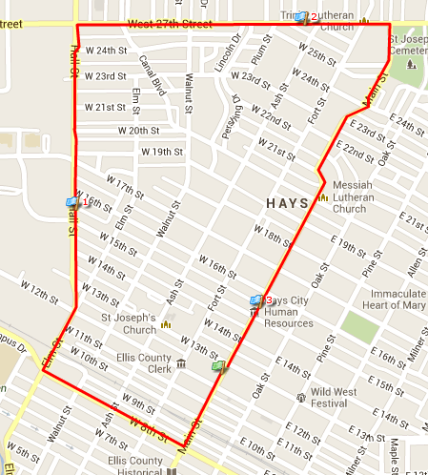

- Start at the Hays Public Library
- Turn right on 8th Street
- Turn right on Elm Street
- Continue on Hall Street
- Turn right on 27th Street
- Turn right on Main Street
- Finish at the Hays Public Library

