Demonstrating The Relevance of Libraries In The Community
with Peter Pearson and Sue Hall
(Library Strategies Consulting Group)

Enjoy Breakfast while listening to experts from Library Strategies.

Date: Wednesday, January 28, 2015
10:00am-12pm

Where: Cost:
Woods Branch $25.00 per person
Grosse Pointe Public Library Limited to 50 people
20680 Mack Avenue Call 313-343-2325
Grosse Pointe Woods MI 48236 Registration Ends Jan. 23, 2015

Peter is the lead consultant with Library Strategies Consulting Group and has been President of The Friends of the St. Paul Public Library for over 20 years. He is recognized as a national expert on all aspects of fundraising for libraries, advocacy, and Friends and Foundations. Pearson was elected to the American Library Association’s Advocacy Honor Roll in 2005.

Sue Hall is the Director of Library Strategies and lead consultant and also coordinates Opus & Olives, the major fundraiser for The Friends of the St. Paul Public Library. Hall has over 20 years of consulting experience with libraries and library organizations. Her consulting services include conducting organizational assessments and facilitating strategic and development planning.

Presented by:
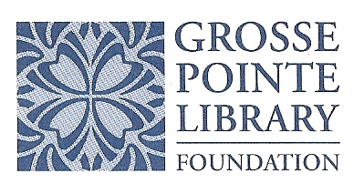 | 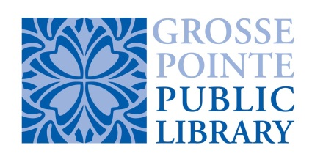 | 