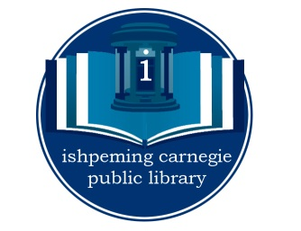

Ishpeming Carnegie Public Library

317 N. Main Street, Ishpeming, MI 49849 906.486.4381•906.486.6226 (fax)

JOB POSTING

POSITION TITLE: Assistant Librarian (40 hours/week, irregular hours)
SALARAY RANGE: $12.91 to $18.29 per hour plus benefits
LOCATION: Ishpeming, MI

Responsibilities include, but are not limited to:
- Cataloging all materials added to the library collection
- Managing inter-library loan services
- Providing patrons with reference and readers’ advisory
- Assisting patrons with library equipment, including public PCs and microfilm reader
- Sorting and shelving books and other library materials
- Creating and maintaining patron records, collecting fines and processing customer requests
- Creating flyers and other promotional materials

Requirements and Qualifications
- Thorough knowledge of the principles and practices of public library functions
- Excellent customer service skills and the ability to work well within a team dynamic
- Ability to supervise the work of others
- Considerable knowledge of the use of computers and other technology in libraries
- Experience with graphics programs and social media preferred
- Physical ability to bend, reach and lift light loads (25+ lbs) required
- Bachelor’s Degree required, with library science undergraduate work desirable. Library experience preferred.
- Must be able to work evenings and occasional Saturdays

Please mail or drop off cover letter, résumé and application at 317 N. Main St. Ishpeming, MI 49849. Applications are available at the library or online at the city of Ishpeming website:
http://ishpemingcity.org/?wpfb_dl=5

