William Shakespeare
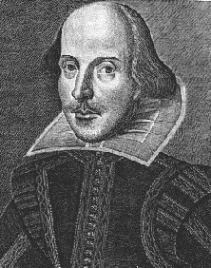
His Life, Times, and Work
As presented by
Jim Glenn,
Theater and speech educator
He will surprise and delight us with tales of Shakespeare’s boyhood in Stratford and how his life in the Elizabethan era influenced and shaped his writings.

6:00 Thursday, December 18
Conference Room in Warren Civic Center
Please call to register: 586-574-4564

