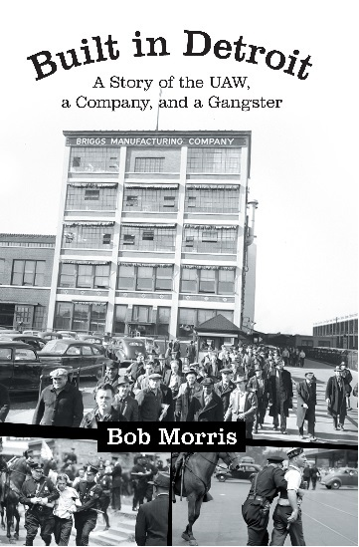
Featuring a Presentation and Book Signing.

Local author Bob Morris presents his father’s firsthand experience at Briggs Manufacturing Co. during the formation and rise of the UAW in the 1930’s and 40’s.

Presentation and Book Signing.
THURSDAY DECEMBER 11
6:00 PM
WARREN CIVIC CONFERENCE ROOM
Please call to register 586-574-4564

