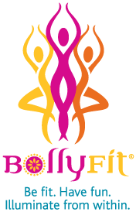
Come and try
the newest
fitness experience….

facebook.com/bollyfit

Mindfulness + Excellent Physical Workout + Indian Dance Styles like Bhangra and Bollywood !
Learn the choreography to a song—remember that final scene in Slumdog Millionaire?
Thursday, November 13, 6:00 PM
Wear comfortable clothes you can move in. You will be encouraged to dance barefoot. Athletic shoes are OK.

Conference room next to Warren Civic Center Library
Please call to register: 586-574-4564

