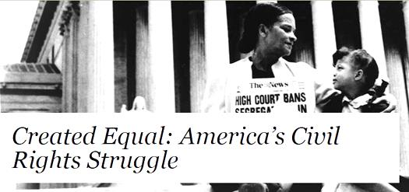

To mark the 150th anniversary of the Emancipation Proclamation, the National Endowment for the Humanities has developed a special project as part of its Bridging Cultures initiative:
Created Equal: America’s Civil Rights Struggle.

Second Event presented by the Warren Public Library
Monday, June 16
6:00 pm
We will feature the documentary Freedom Riders.
This film tells the terrifying, moving, and suspenseful story of a time when white and black volunteers riding a bus into the Deep South risked being jailed, beaten, or killed, as white local and state authorities ignored or encouraged violent attacks. The film includes previously unseen amateur 8-mm footage of the burning bus on which some Freedom Riders were temporarily trapped, taken by a local twelve-year-old and held as evidence since 1961 by the FBI.

Christopher Schimers, Macomb County Community College Librarian, will lead a discussion of the film and civil rights issues of today.

Conference room of the Warren Civic Center
Please call to register: 586-574-4564
Refreshments will be served.
Created Equal: America’s Civil Rights Struggle is made possible through a major grant from the National Endowment for the Humanities, as part of its Bridging Cultures initiative, in partnership with the Gilder Lehrman Institute of American History.

