Warren Public Library proudly presents the Irish band

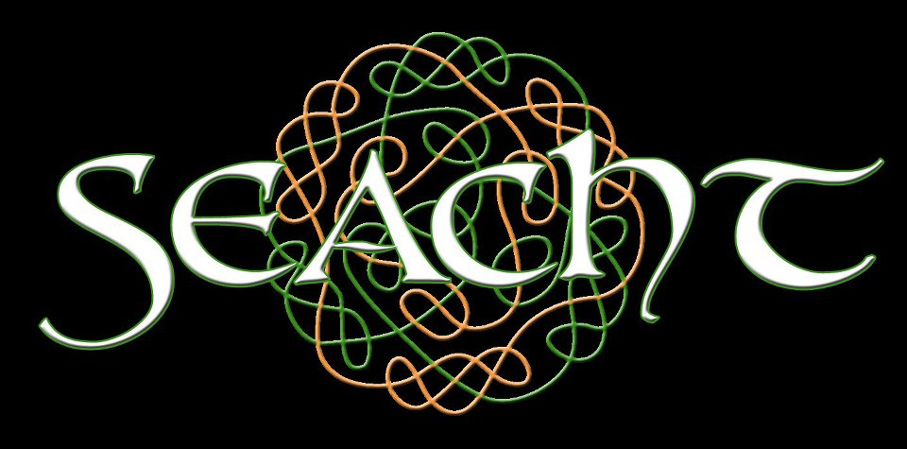

Seacht (pronounced “shocked”) is an Irish music band made up of musicians from Metro Detroit. Seacht plays both traditional tunes and songs using traditional instruments.

“Poor is the person who is without music.”
-an old Irish saying

Monday, June 23 @ 6:00

Conference room next to Warren Civic Center Library
Please call to register: 586-574-4564

