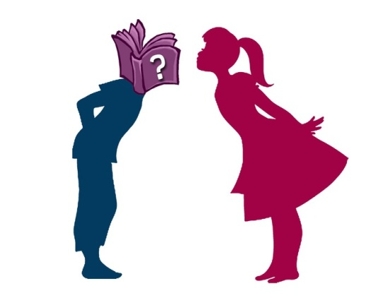
Blind Date with a Book for Teens.
Have a Blind Date Tonight…
Single?
In a relationship?
“It’s complicated”?
No matter!
You can head MacDonald Public Library and have a mysterious rendezvous. Simply pick-up one of the wrapped books on the new book shelf in the teen section of the library. They are all wrapped in paper so you won’t know the identity of your blind date until you get it home. Will it be fiction or non-fiction, funny, informative, entertaining or heart-breaking?
Spend some time getting to know your date. There will be no uncomfortable questions to answer, no awkward lulls in the conversation, no need to put on nice shoes (or even get out of your pajamas). Sure, you might be disappointed; but then again.... you may end up having a great time with something you would otherwise never have ventured to read.
Even if your date turns out to be a dud, (don’t worry; its feelings won’t be hurt), all is not lost! You might get lucky; if not in love then perhaps in literature.

