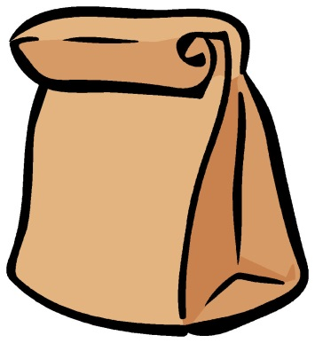

**You don’t know the title.**

**You don’t know the author.**

**You don’t even**

**know what**

**it looks like!**