Jazz Music & History

One summer day in 1958 a young photographer took a picture of dozens of America’s jazz legends all gathered in one place. This famous photograph became known as…
A Great Day in Harlem
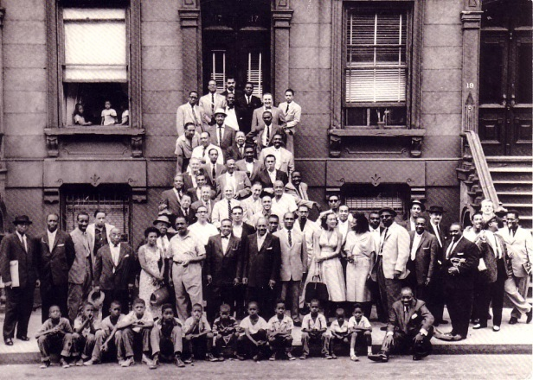
Join jazz expert Stu Johnson as he takes us back to that fateful day with the back story, photos and, of course, great music.

Tuesday, January 14
@ 6:00

Conference room next to the Warren Civic Center Library
Please call to register: 586-574-4564

