

Holiday Music Past and Present

with Pianist/Composer

Deborrah Wyndham

(You may have seen her on FOX, NBC or ABC TV!)

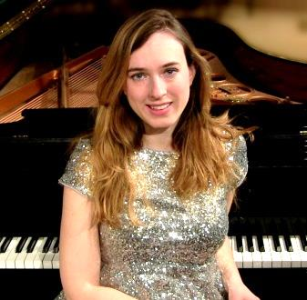

http://deborrahwyndham.com/

With styles ranging from contemporary to classical to jazz and ragtime, Deborrah will play her own arrangements of traditional and popular holiday pieces. She will also share interesting facts about the songs and their composers.

Monday, December 16

6:00

C:\Users\Jamie Babcock\AppData\Local\Microsoft\Windows\Temporary Internet Files\Content.IE5\784F04HN\MC900439973[1].wmfConference room next to Warren Civic Center Library

C:\Users\Jamie Babcock\AppData\Local\Microsoft\Windows\Temporary Internet Files\Content.IE5\156K7OX3\MC900439959[1].wmfC:\Users\Jamie Babcock\AppData\Local\Microsoft\Windows\Temporary Internet Files\Content.IE5\H8F5N4UC\MC900439955[1].wmfPlease call to register: 586-574-4564

