Warren Public Library is pleased to present…
Jeanne Sirotkin
Poet, Novelist, Winner of
Stephen F. Austin Prize for Fiction and
Author of Wrestling the Bear
http://www.jeannespage.com/
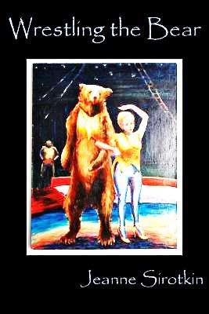
…an odd and offbeat look
at the world in all of its
great sadness and folly.
Bravo. And bravo again!
---Jack Driscoll
Author of The World
A Few Minutes Ago

Monday, October 7 at 6:00
Books will be available for sale and signing

Conference room next to Civic Center Library
Please call to register: 586-574-4564

