It’s murder at RADL!!!!!
These mystery authors base their stories in Michigan! Read one today and then come to the author talk!

BRYAN GRULEY AT RADL JULY 25TH at 6 pm!
Bryan Gruley is the critically acclaimed author of Starvation Lake: A Mystery, and the sequel, The Hanging Tree. Starvation Lake was nominated for an Edgar Award for Best First Novel by the Mystery Writers of America, and won the Anthony, Barry, and Strand awards. Reviewers have compared Bryan to novelist Dennis Lehane. Secretly, though, Bryan would love to be compared favorably to Detroit Red Wings stars Johan Franzen and Pavel Datsyuk. He’s been playing hockey since he was a boy growing up in Detroit. Hockey plays a role in the life of the fictional town of Starvation Lake, as do two of Bryan’s other passions, northern Michigan and newspapers.

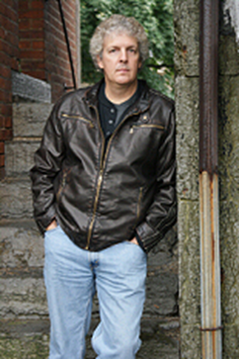
Steve Hamilton at RADL July 31^{st-} 3:30 pre-signing, 4pm talk!
Born and raised in Detroit, Steve Hamilton graduated from the University of Michigan. In 2006, he won the Michigan Author Award for his outstanding body of work. His novels have won numerous awards and media acclaim beginning with the very first in the Alex McKnight series, A Cold Day in Paradise, which won the Private Eye Writers of America/St. Martin's Press Award for Best First Mystery by an Unpublished Writer. His novel The Lock Artist won the 2011 Edgar Award. The awards didn't stop there but he's too modest to crow about them.

